import json
import boto3
import datetime

dynamodb = boto3.resource('dynamodb')
table = dynamodb.Table('S3Events') # DynamoDB table name

def lambda_handler(event, context):
print("Received event: ", json.dumps(event, indent=2))

for record in event['Records']:
event_name = record['eventName'] # Event type (ex: ObjectCreated, ObjectRemoved)
bucket_name = record['s3']['bucket']['name'] # Bucket name
object_key = record['s3']['object']['key'] # Object key (file name)
event_time = record['eventTime'] # Time of event

# If object is deleted, size field may not exist
object_size = record['s3']['object'].get('size', 0)

# Store event details in DynamoDB
table.put_item(
Item={
'ObjectKey': object_key,
'BucketName': bucket_name,
'EventName': event_name,
'ObjectSize': object_size,
'EventTime': event_time
}
)

print(f"Logged {event_name} for {object_key} in {bucket_name}")

return {
'statusCode': 200,
'body': json.dumps('Event logged successfully!')
}

Lambda function
Scenario:
Any action taken (get,post,delete) will automatically trigger Lambda function and store the object details(bucket-name,even-time,object-size) etc in DyanamoDB database

Steps:
- Create a bucket with any name
- Create IAM-role with dyanamoDB permission
- Create dyanamoDb table (S3 events)mentioned as in code
- Create a lambda function

Create S3 bucket
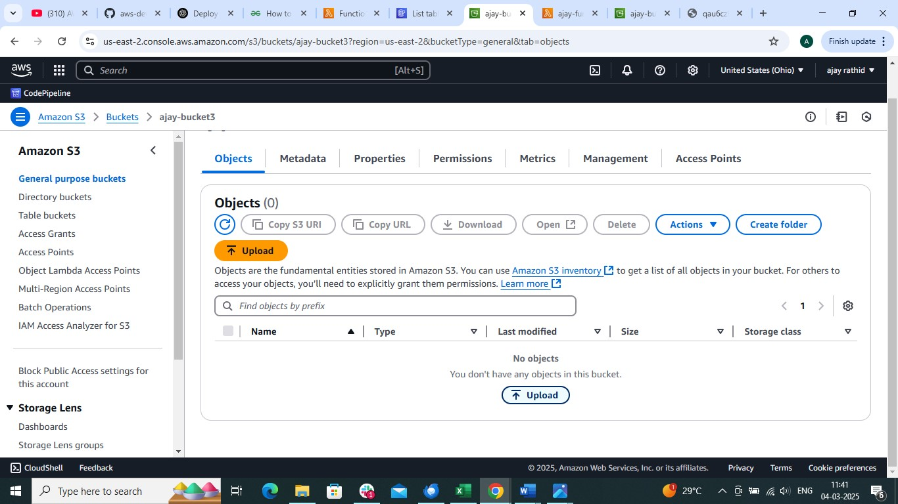

Create DynamoDB table (S3Events)
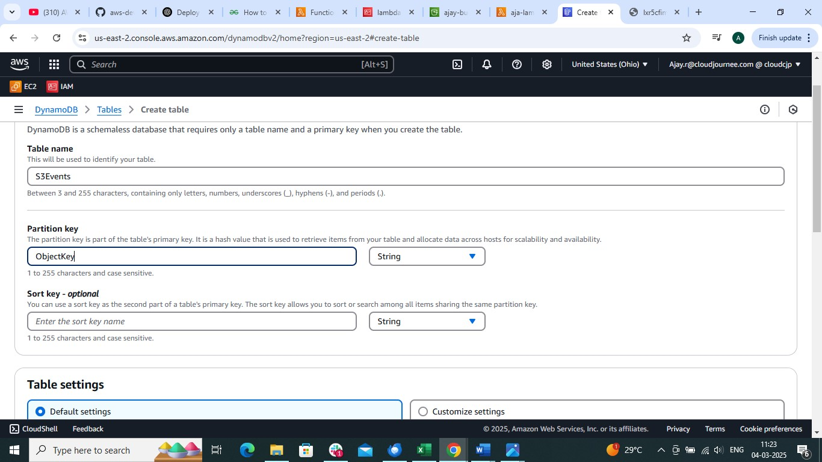

Create Lambda function and attach role
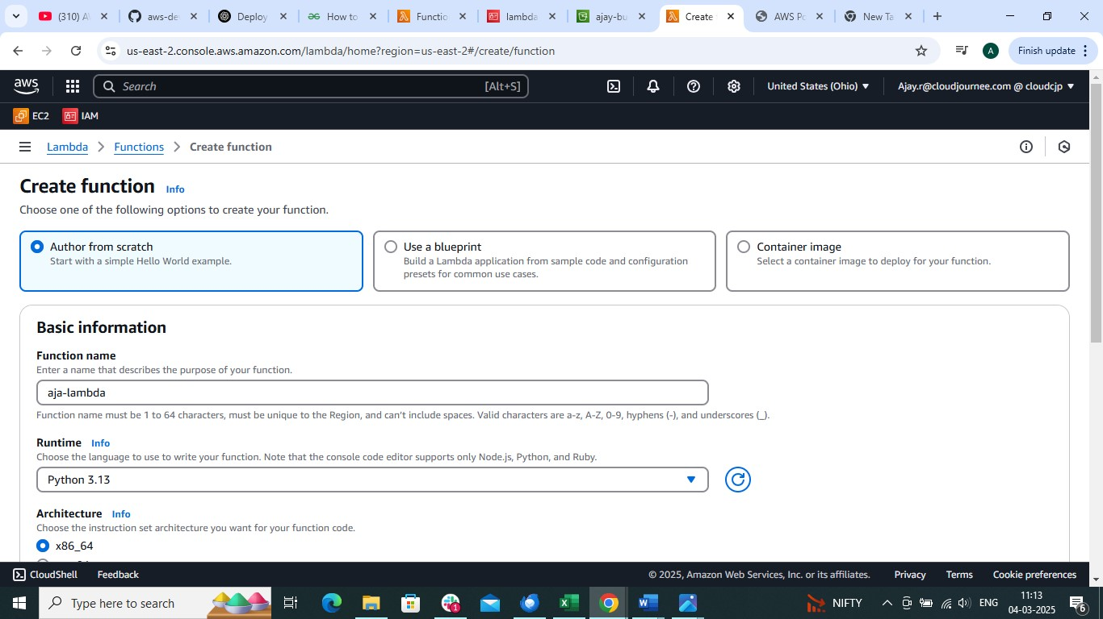

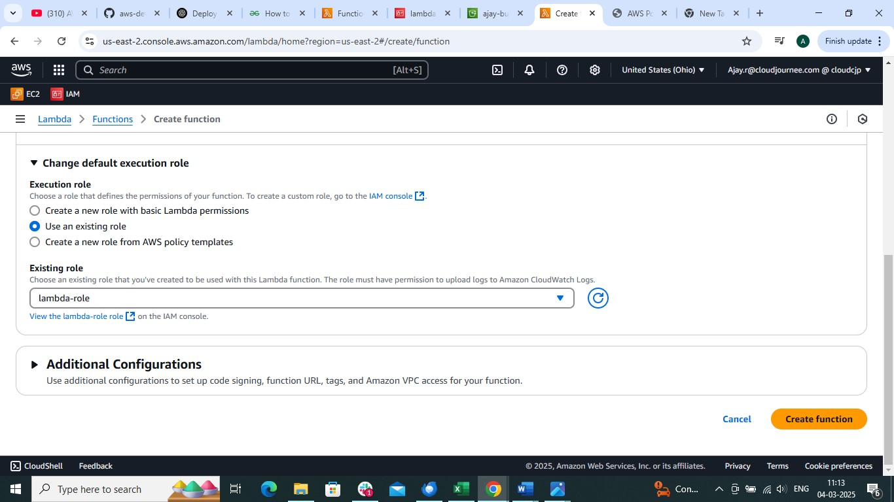

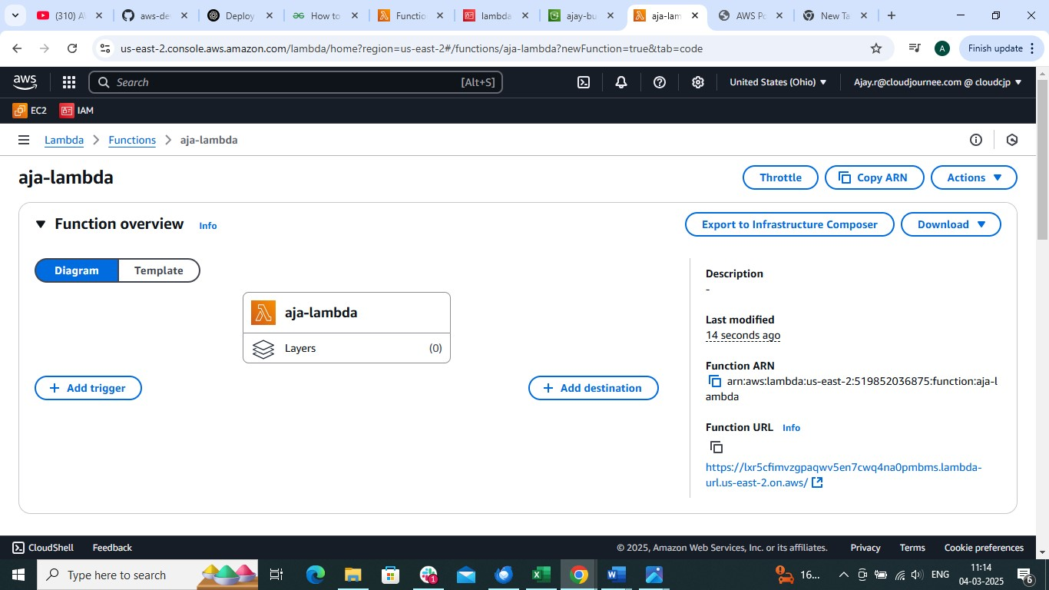

And use above python code (1st page)

Add trigger

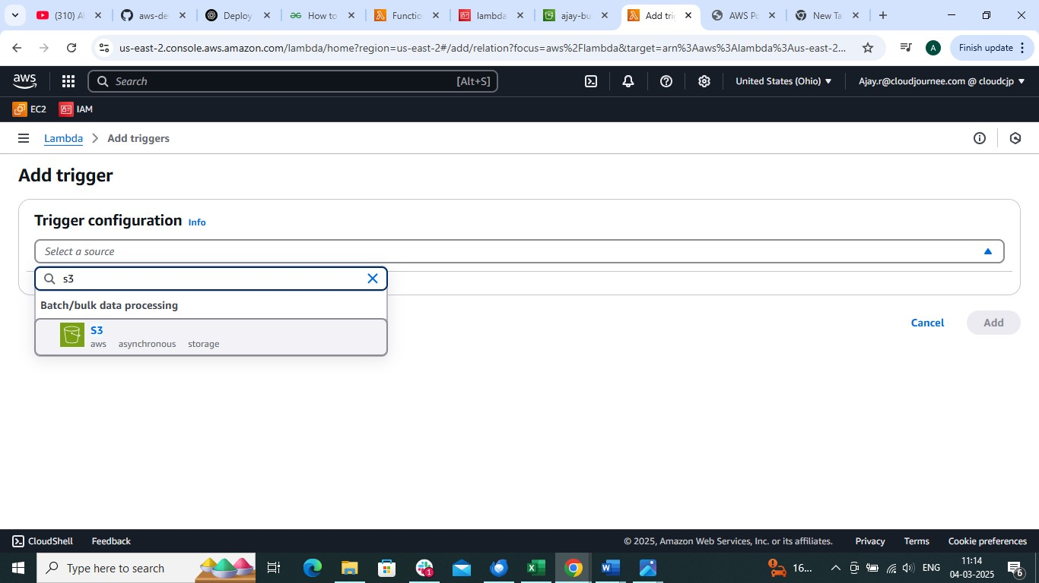

Choose event type
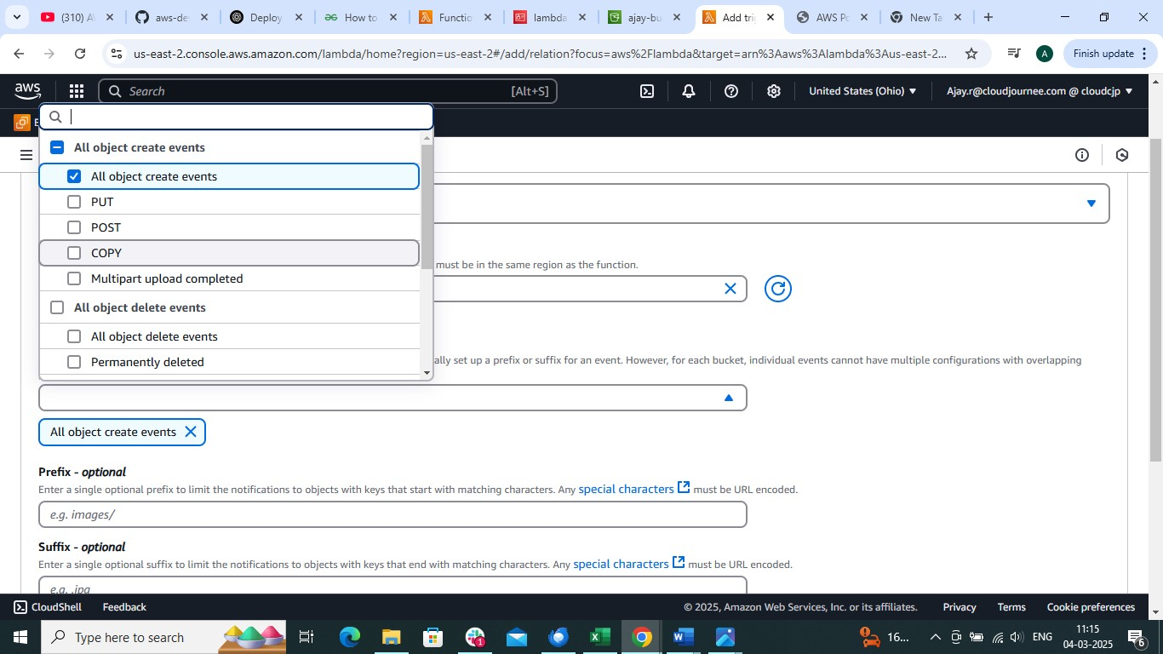

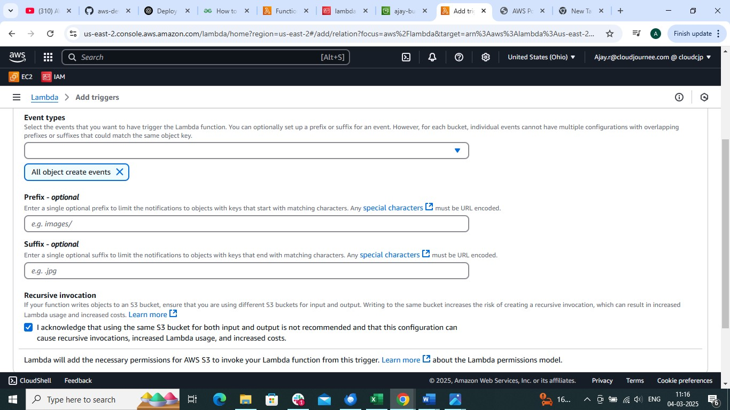

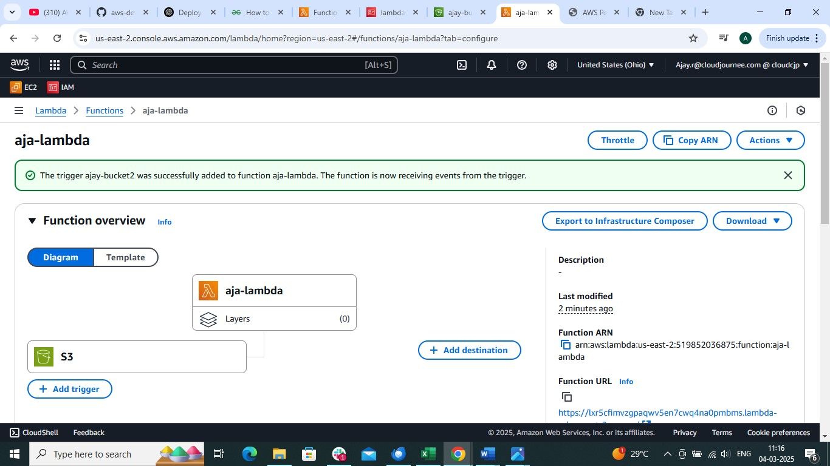

now add file or delete file from bucket .it will trigger lambda function and add details into dynamoDB

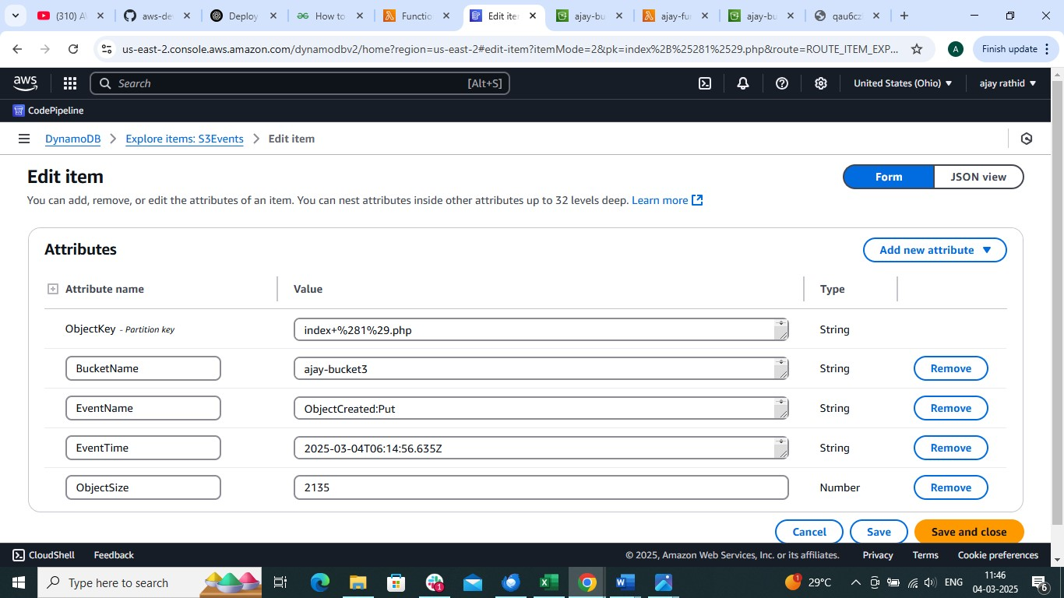

To Create lambda layer ( to add dependencies for python code)
Open cmd
mkdir faker_layer # with any name (dependency name)
cd faker_layer
mkdir python

Inside faker_layer directory, run this command ( to install pip install faker -t python/

Now compress it into zip file ( Open PowerShell enter into faker_layer directory)
Compress-Archive -Path python -DestinationPath faker_layer.zip

The structure would be
faker_layer.zip
└── python/
├── faker/
├── psycopg2/ (optional)
└── other dependencies...

Now open lalmbda layer add layer and choose .zip file

And then use it in in lambda layer

